BILL OF MATERIALS
Product: PENNINGTON 7 LB DISPLAY
Pouch Specifications:
- Pouch is black with a flower scene on front
- Dimensions of pouch are: L 13” x W 10.25” x 4” GUSSET
- Pouch fitted with gusseted bottom and zipper top
Pouch Machine Recipe:
- Select program titled (7LB) on Leepack machine
- Use program #7 on the scales
- Set speed at 22 per minute
Display Specification:
- Display Case is brown corrugated
- Display case inside dimensions are: 36W” X 47L” 12 slots 11-1/2” X 11-1/2” X 13-3/4”
- Unit of measure is ( Set )
- One set is made up of five pieces: Header ( 1pc.) tray ( 3pcs.) pallet wrap (2 pcs.) part A ( 4pcs. ) part B (6pcs.)
Packing Specification:
- Bottom layer 10 outside slots with 5 pouches and 2 inside slots with 7 and 6 pouches per, packed two vertically balance horizontally into slots
- Top layer 10 outside slots with 5 pouches and 2 inside slots with 6 and 6 pouches per, packed two vertically balanced horizontally into slots
- Date code to be applied both to pouch
- Date code must placed on front of pouch on the cream colored flower bottom left side
- The four digit date code represents the date of packaging (i.e. 02-09-2009 = 0409 which means the 40th day of the year 2009
- The { EXP } means expiration which is three years ( i.e. EXP 0212 ) The 0212 means the second month of the year 2009
- Wrap bottom layer with clear tape after top layer is placed on to of bottom layer
- 125 pouches/ pallet 63 on bottom layer 62 on top layer, triple stretch wrap
- No slip sheet on pallet
- Numeric order of production (i.e.1,2,3,4) and date of manufacture to be written outside stretch wrap
- Pallets may not be double stacked in warehouse
Pallet Configuration:
- 63 pouch on bottom layer and 62 pouches on top layer = 125 pouches per pallet
SHIPPING INFORMATION:
- Pennington pallets require a bar coded sticker on all four sides of pallet stickers with the BOL.

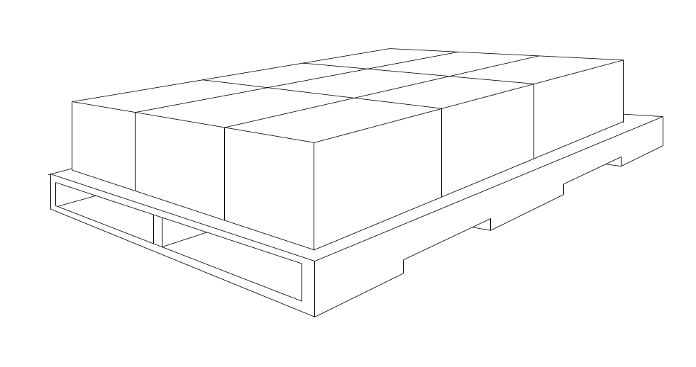

Rev: 00
Date: 03/30/2011

